**Table scripts :**

**Table-1: Customer Details**

**Creation:**

CREATE TABLE CUST_DETAILS(CUST_ID NUMBER,FIRST_NAME VARCHAR2(10),LAST_NAME VARCHAR2(10),CUST_AGE NUMBER,CUST_CONTACT NUMBER);

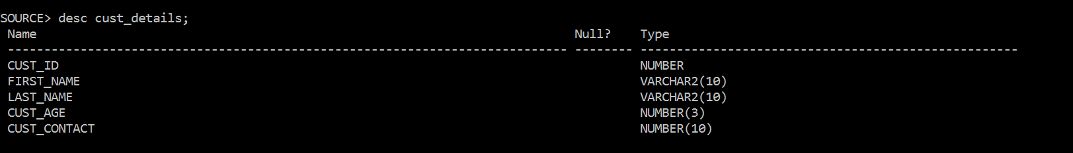

**Insertion:**

INSERT INTO CUST_DETAILS(CUST_ID,FIRST_NAME,LAST_NAME,CUST_AGE,CUST_CONTACT) SELECT ROWNUM,DBMS_RANDOM.STRING('U',7),DBMS_RANDOM.STRING('U',5),

FLOOR(DBMS_RANDOM.VALUE(11,45),FLOOR(DBMS_RANDOM.VALUE(7000000000,9999999999)

FROM DUAL CONNECT BY LEVEL<=100;

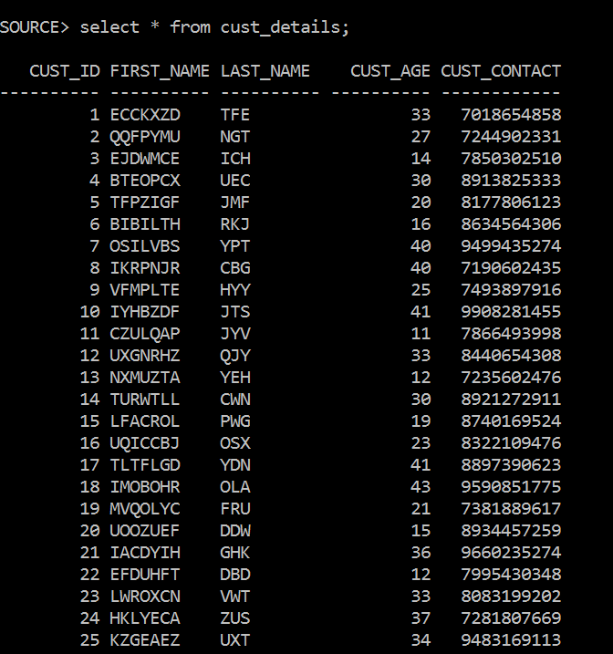

**Table-2: Product Details**

**Creation:**

Create table product_group 2(Product_id number, Product_name varchar2(20), Price number (7, 2), Category varchar2(20) ) ;

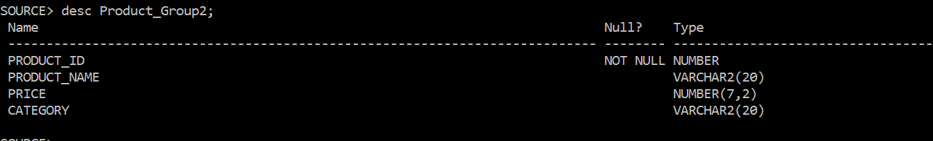

**Insertion:**

Insert into product_group2 values (1,'Caffee Latte',100,'Bevrage');

Insert into product_group2 values (2,'Caffee Mocha',120,'Bevrage');

Insert into product_group2 values (3,'White Choclate Mocha',130,'Bevrage');

Insert into product_group2 values (4,'Skinny Peppermint',90,'Bevrage');

Insert into product_group2 values (5,'Tosted Grahm Latte',100,'Bevrage');

Insert into product_group2 values (6,'Cappuccino',80,'Coffee');

Insert into product_group2 values (7,'Espresso',100,'Coffee');

Insert into product_group2 values (8,'Iced Coffee',120,'Coffee');

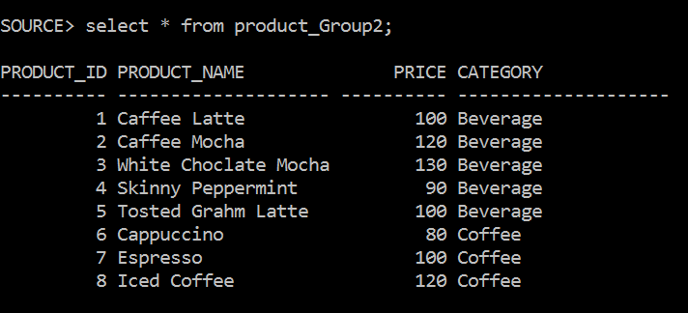

**Table-3: Order Details**

**Creation:**

CREATE TABLE ORDER_2(ORDER_ID NUMBER, CUST_ID NUMBER , PRODUCT_ID NUMBER, ORDER_DATE NUMBER, ORDER_QUANTITY NUMBER ,TOTAL_PRICE NUMBER)

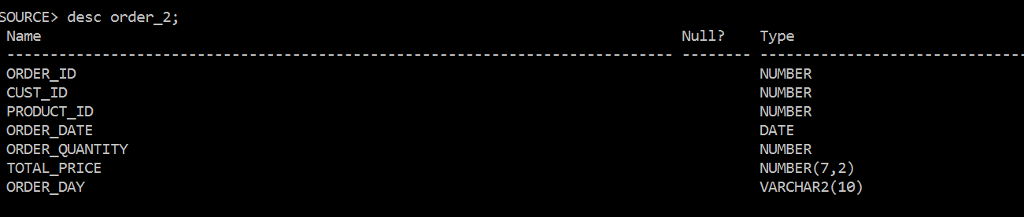

**Insertion:**

INSERT INTO ORDER_2(ORDER_ID, CUST_ID, PRODUCT_ID, ORDER_DATE, ORDER_QUANTITY, TOTAL_PRICE) SELECT ROWNUM, FLOOR (DBMS_RANDOM. VALUE (1,100)), FLOOR (DENS RANDOM.VALLE (1,8),TRUNC (SYSDATE)-FLOOR (DBMS_RANDOM. VALUE (10,900)),

FLOOR (DBMS_RANDOM. VALUE (1,10)), FLOOR (DBMS_RANDOM.VALUE (150, 2000)) FROM DUAL CONNECT BY LEVEL<= 100;

